**EXPERIMENT 9**

**VIEWS**

**Aim:**

* Create table student with attributes id, name and department.
* Display

**create table view_student_(student_id int,student_name varchar(20),department varchar(20));**

**insert into view_student_ values(1,'Rihan','CSE');**

**insert into view_student_ values(2,'Deepika','IT');**

**insert into view_student_ values(3,'Vivek','ECE');**

**select * from view_student_;**

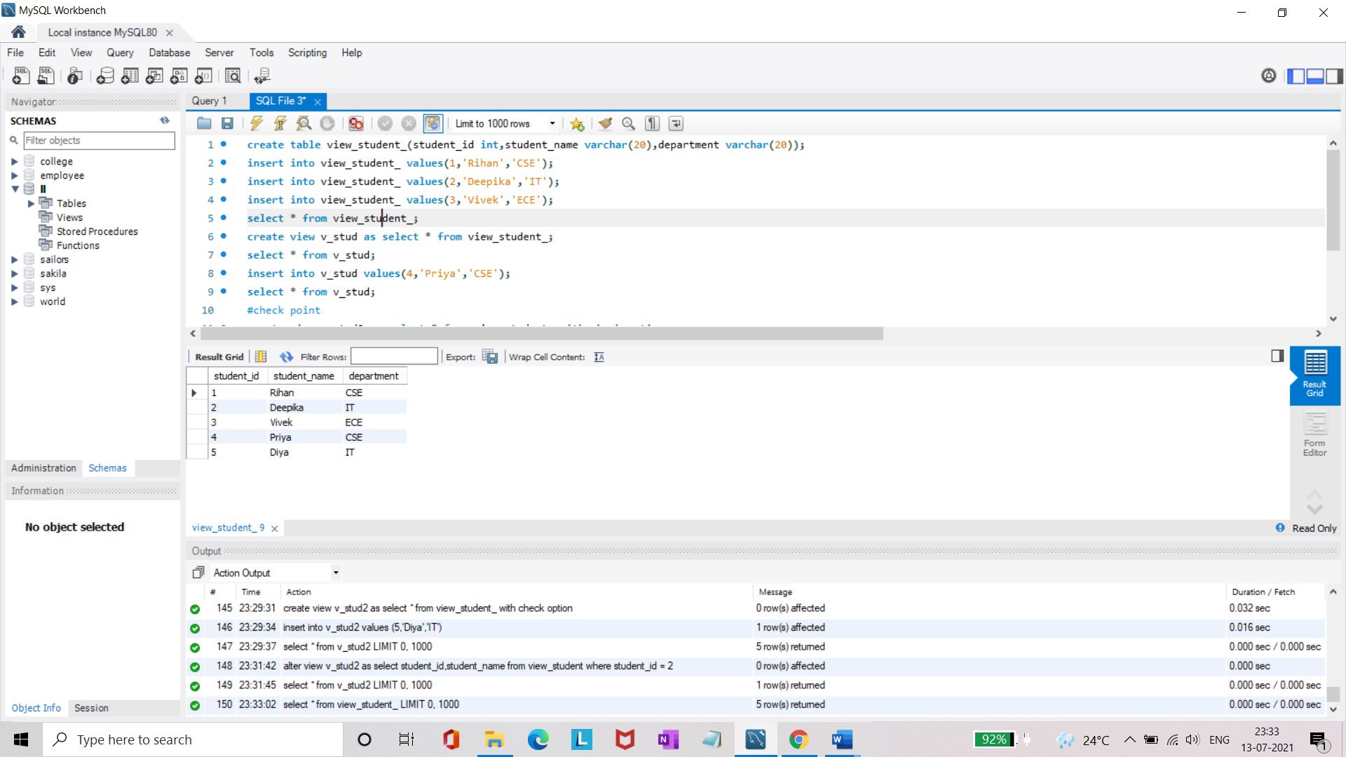

* Create view and select

**create view v_stud as select * from view_student_;**

**select * from v_stud;**



* Insert values

**insert into v_stud values(4,'Priya','CSE');**

**select * from v_stud;**

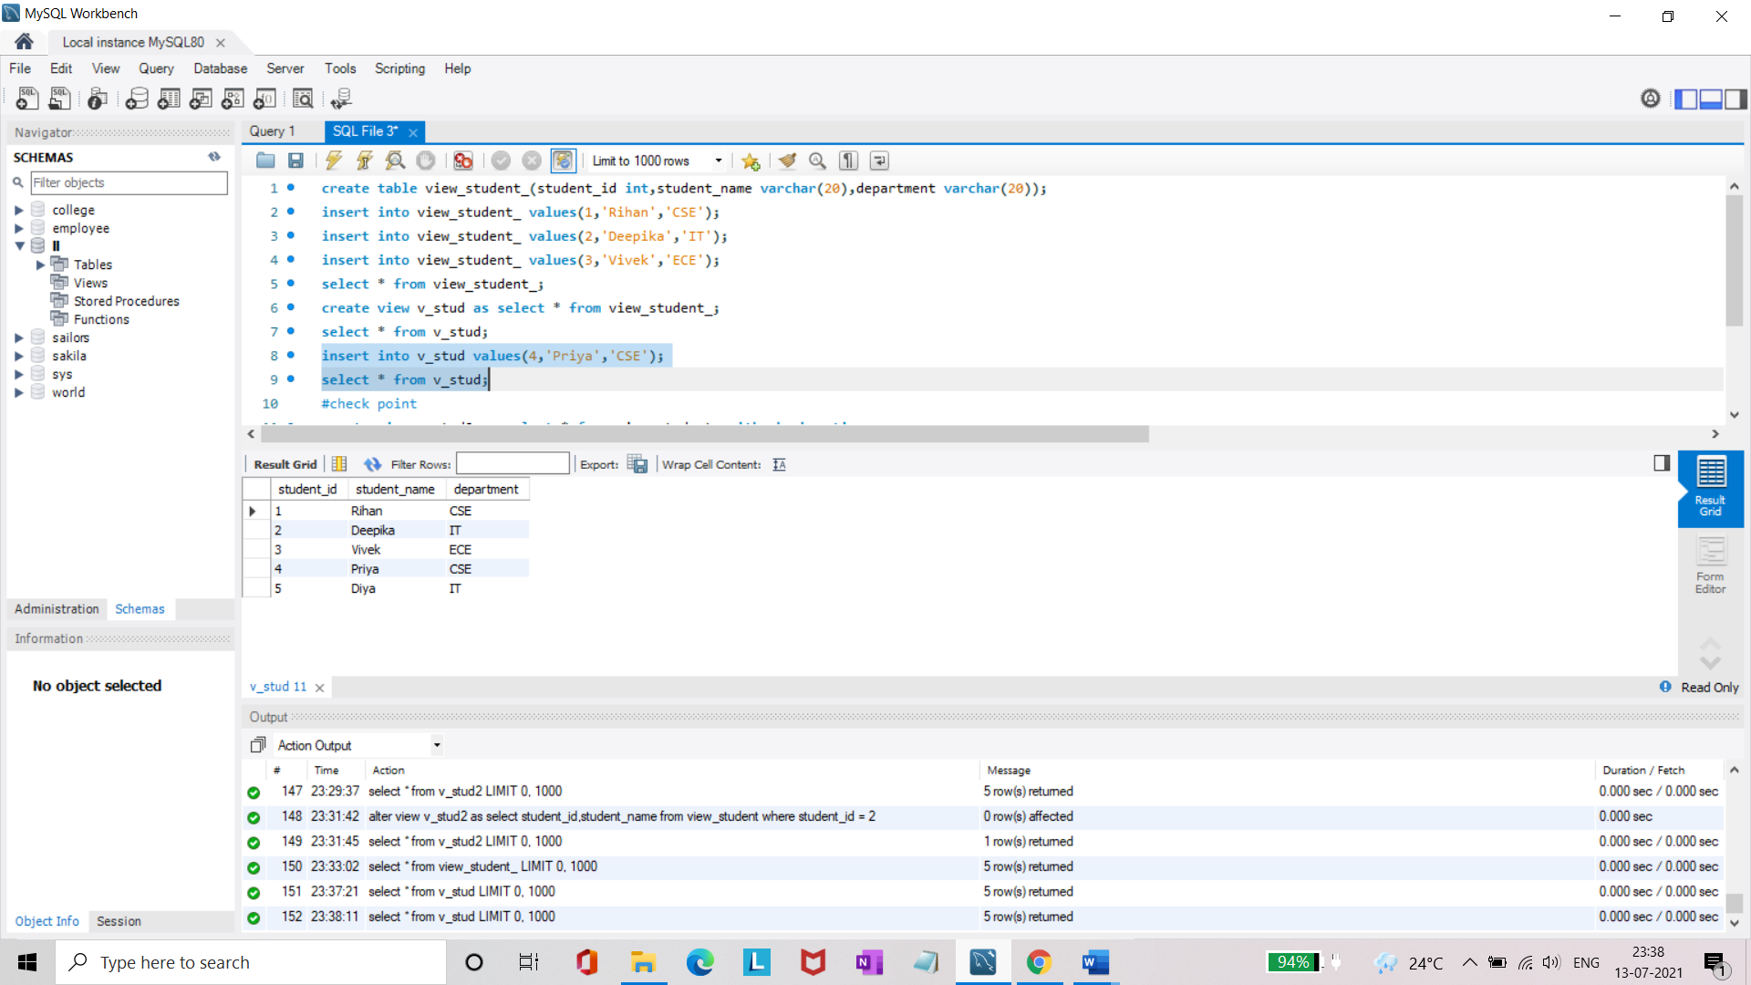

* Create view with check option
* Insert values and alter table.

**#check point**

**create view v_stud2 as select * from view_student_ with check option;**

**insert into v_stud2 values (5,'Diya','IT');**

**select * from v_stud2;**

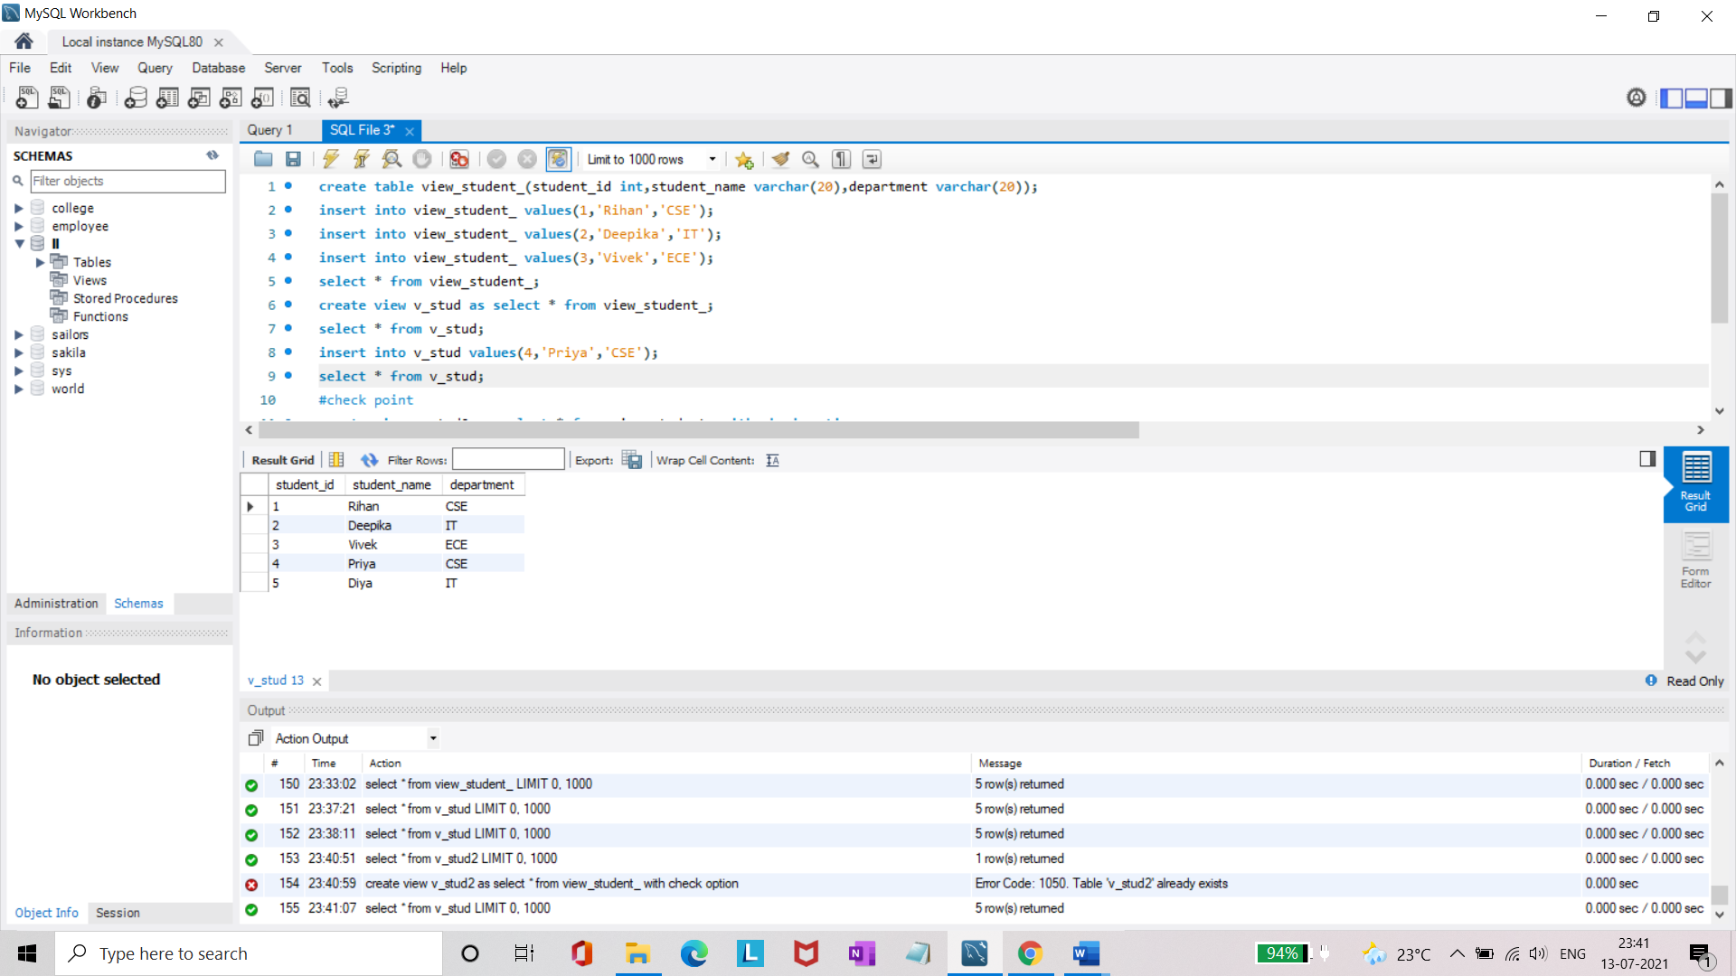

**alter view v_stud2 as select student_id,student_name from view_student where student_id = 2;**

**select * from v_stud2;**

